Heap leak:

1. Set VM parameter: 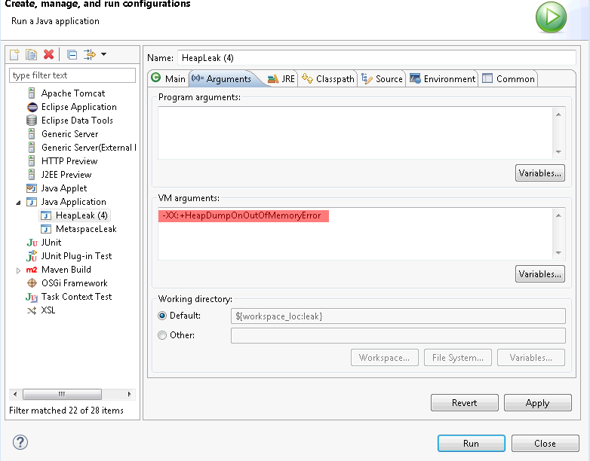
2. Run HeapLeak class from Task3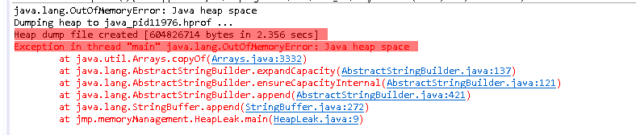
3. Opened created heap dump with memory analyzer tool. It showed the “Leak Suspects” info

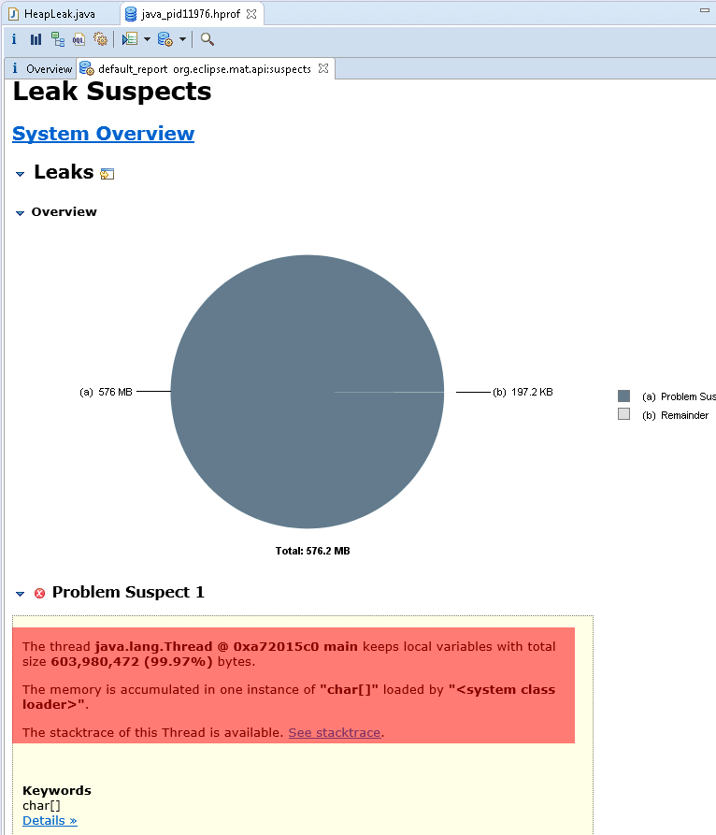

1. There is possibility to see all object in heap

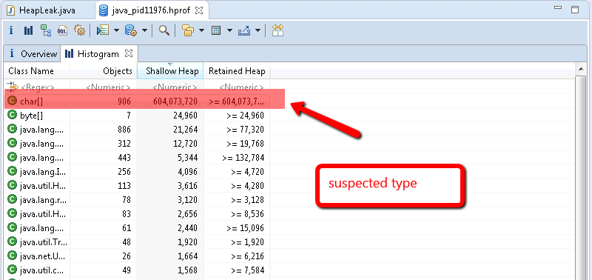

1. List of instances

